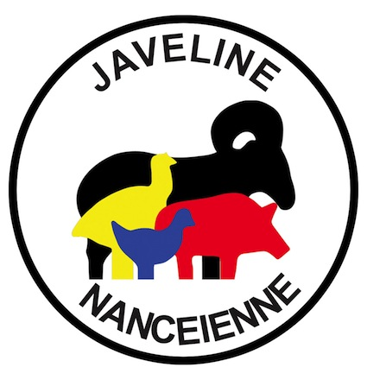 | LA JAVELINE NANCEIENNE  Tir Sportif (FFTir n° 1254012)  *  Siège : 15 Bd d’Haussonville F-54000 -NANCY  Courrier : La Javeline Nancéienne BP 83894 54029 NANCY Cedex  Président : Frédéric FEVE  Mail : javelinenancy@gmail.com  Phone : +336 48 38 25 11
 | Nancy, 07/31/2017

Dear friends shooters,

Our club organize september 30th and october 1st 2017 a friendly Challenge of Metallic Silhouettes. This challenge will be governed by the official regulations FFTir IMSSU (shoot 5 targets, 1mn break, 5 targets) and will include the following disciplines:

SMALL BORE | revolver  production  unlimited  standing | BIG BORE | revolver  production  unlimited  standing
FIELD PISTOL | Open sight  Optical sight | RIFLE | Light rifle 22LR  Silhouette rifle 22LR

This challenge will take place at EUROSTAND of VOLMERANGE LES MINES (57330).

Entries duly completed with names of shooters and coaches must be received:
- Regular mail: LA JAVELINE NANCEIENNE BP 83894 54029 NANCY Cedex
- Or email to javelinenancy@gmail.com
- Or electronic form https://docs.google.com/forms/d/e/1FAIpQLSeK6FMshtUOASPzbrTueI1JoHWSqNcjnysnAfZT_iCXvnAb4w/viewform?usp=sf_link
for september 18, 2017 later

The entry price per discipline is 15 euros, paid before the match. The coaches will ensure the lift up to 100 m and the marking of the points. In the case of multiple shots for a tandem coach-shooter we will spread the matches over 2 days beyond 4 engagements for each of the 2 in total. For the 3 aggregates Small Bore, Big Bore and Standing, the 4th match will be offered.

If the timing allows, the ties will be divided by barrages displayed at the stand. These barrages will take place by 2X5 beasts, renewable 3 X maximum, if equal. In opposite cases, reverse counting of the targets if possible

The awards ceremony will take place on Sunday, October 1 at 5 pm.

We are waiting for your reply and receive our best sports greetings.

The President
Frédéric FEVE
